iSTEM
Integrated, Science, Technology, Engineering and Mathematics
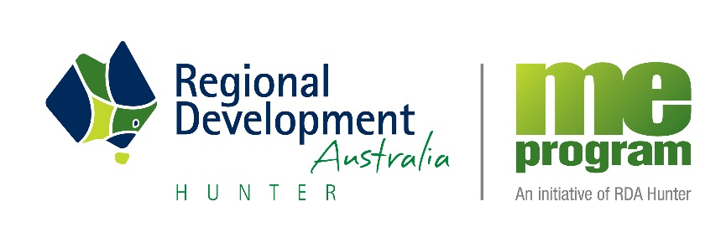

The imperative of STEM skills
STEM refers to science, technology, engineering and mathematics. The basic contributors to healthy STEM are research, international engagement and education. The importance of STEM disciplines for the future economic and social well-being of Australia cannot be underestimated. International research indicates that 75 per cent of the fastest growing occupations require STEM skills and knowledge. In the US STEM employment grew three times more than non-STEM employment over the past twelve years and is expected to grow twice as fast by 2018.

“The number of people in jobs commonly held by workers with science, technology, engineering and mathematics (STEM) qualifications grew by 14 per cent between 2006 and 2011. This compares with only nine per cent growth for other jobs. Many people have caught on with the trend, with around 2.1 million workers in Australia having STEM qualifications in 2010-11.”

Sources: AI Group 2015 and Office of the chief Scientist 2015

Selection into the iSTEM, is predominately by invitation only. Students are selected due to their outstanding aptitude in Mathematics, Science and Problem Solving and successful students will be notified by letter in the middle of Term 3. However, students with a particular interest in STEM subjects may self-nominate via the Head Teacher, Teaching and Learning, Dr Sleap. The class runs parallel to elective lines and therefore students will only choice two electives.

iSTEM is a School Developed Board Endorsed Course which was developed by Regional Development Australia – Hunter, Maitland Grossmann High and industry partners. This means that student success is recognised on their Record of School Achievement (RoSA) in Year 10. It has been an outstanding success and in 2016 will be adopted by around 140 schools throughout NSW. It covers a number of modules in the fields of science, technology and engineering.

Class members have the option to participate in a variety of competitions and STEM based intervention programs during the course. Students will also study a variety of themed units of work focusing on the application of science, technology, engineering and mathematics to real life, through inquiry based learning techniques.

STEM activities may include
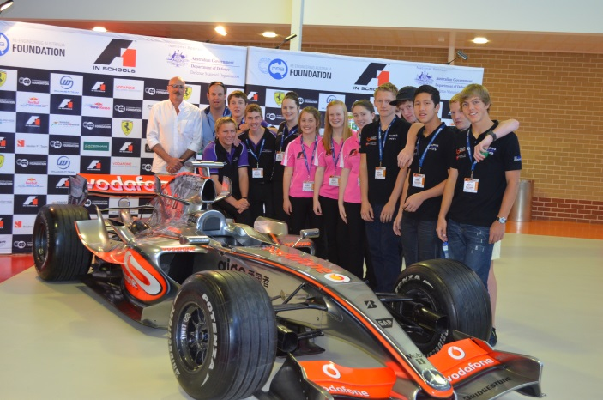
- Science and Engineering Challenge
- Electric Vehicle Festival
- F1inSchools
- Challenge days
- RoboCUP and Robotics Challenge days
- Excursions e.g CSIRO, University of Newcastle, etc
- Major Research Projects
- The National Science Poster Competition

The main purpose of this NSW Educational Standards Authority (NESA) endorsed course is to better engage students in science, technology engineering and mathematics. It is meant to challenge and excite students with the possibilities of the future. It involves many 21st century learning opportunities and emphasises inquiry based learning where students are encouraged to learn by doing.

The importance of STEM subjects to Australia is indisputable. Future employment opportunities for our students will be enhanced with STEM based knowledge. In 2012, Ian Chubb, Chief Scientist of Australia triggered a major focus on the decline of interest in STEM studies across the nation and its potential impact on our future. To this end we are excited to be able to offer this opportunity to the students of the school.

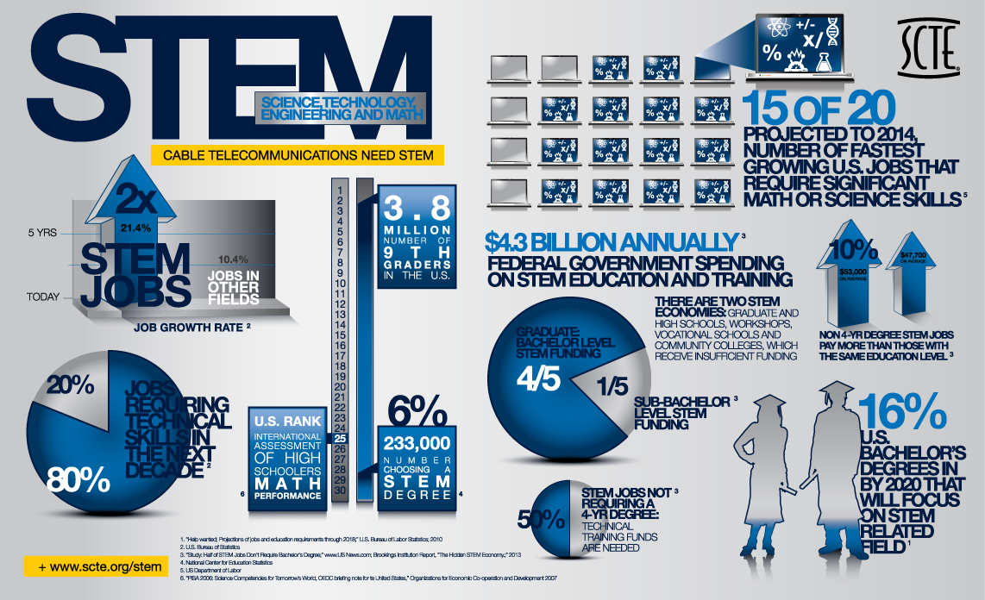
For further information do not hesitate to contact the schools STEM coordinator Dr Scott Sleap 02 49408355 email scott.sleap@rdahunter.org.au

