iSTEM Module 14: Biomedical Innovation | Abstract  A student approach to designing a basic biomedical ventilation system. Supported by Central Coast Academy of STEM Excellence, Ampcontrol and NSW Department of Health  STUDENT NAME  STUDENT WORKBOOK & FINAL BIOMEDICAL REPORT TEMPLATE

TABLE OF CONTENTS
Abstract 1
Table of Contents 2
List of TABLES #
List of FIGURES #
Introduction #
Background #
Problem Statement
Lung Volume #
Background #
Experimental Set-up #
Results #
Discussion #
Breaths per minute #
Background #
Experimental Set-up #
Results #
Discussion #
Inhale : Exhale Ratio #
Background #
Experimental Set-up #
Results #
Discussion #
Ventilation System #
Background #
Experimental Set-up #
Results #
Discussion #
Conclusion #
Future Works #
Appendicies #
Appendix one #
Appendix TWO #

INTRODUCTION
In this report, students develop skills and understanding associated with biomedical innovation, specifically design of a medical innovation and biomedical engineering.
Students are to use this template to develop skills and understanding associated with a biomedical innovation created by Ampcontrol and complete a report demonstrating their knowledge and understanding of the STEM Process affiliated with creating this innovation. Students will utilise inquiry and problem-based learning strategies to investigate the worldwide pandemic COVID-19, which has affected the way we live and medically treat patients who have contracted the virus. Students roleplay as engineers who have been approached by NSW Health to investigate and design a basic biomedical ventilation system, to assist the increased demand for respiratory care and support for the increasing number of patients requiring medical support.
The STEM Process which will be applied as a scaffold to learning is outlined in the list of figures.

LIST OF TABLES
Students are to place the use of any tables here

LIST OF FIGURES
STEM PROCESS
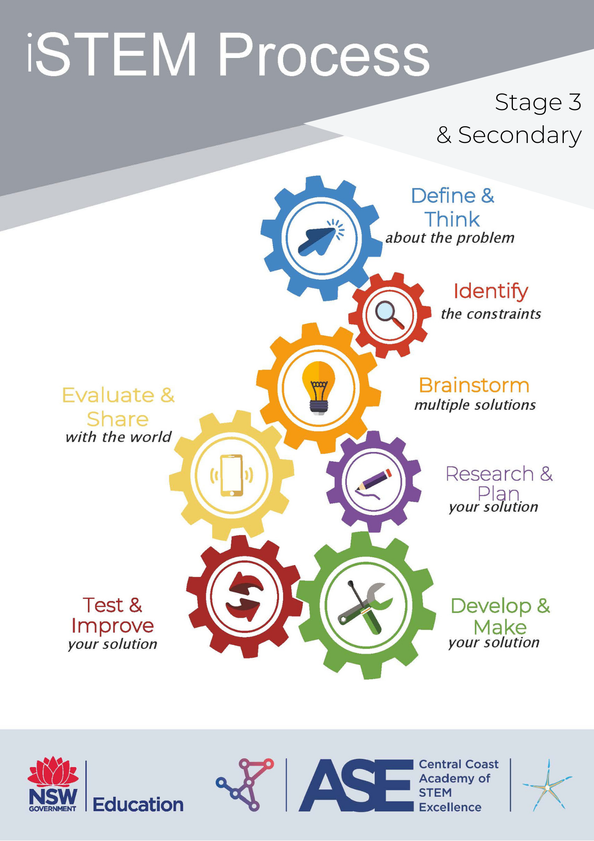

LESSON 1: LUNG VOLUME
BACKGROUND
“You are a Biomedical Engineer working at Ampcontrol and your supervisors have just called you in for a meeting. They inform you that you will be a part of one of the teams working to develop a ventilator in response to COVID-19. The time frame is strict and you will be required to work quickly and accurately. You and your team have never faced such a problem and the following lessons have been designed to give you the relevant knowledge and skills to undertake the task you have been assigned.
In this lesson you will be required to investigate the lung volume, breaths per minute and Inhale: Exhale ratio of a human being. You will also need to deduce the relevance and significance of your findings.”
STEM PROCESS | TASK | STUDENT WORK/ NOTES
INVESTIGATION INTO LUNG VOLUME
DEFINE the problem
How do lungs work and how can you determine an individual’s lung volume to assist their breathing when they have contracted COVID-19?
Introduction:
- Overview of the STEM Process application
Watch: COVID-19 Pandemic Headline
Watch: Ampcontrol Video 1: Introduction – Tiana and Ruvimbo and setting the scene for relevance

Back story:
THINK
- What is Lung volume?
- Why would lung volume be important to know in the design of a respirator
- Students provided with the assessment

Explain the ‘Problem’
  - High level of casualties being admitted to hospitals
  - and minimal amount of respirators
  - Students are novice engineers with minimal knowledge of biomedical respiratory systems and/ or lung operation

Watch: Ampcontrol Video 2: Chris Bird – Research Methodology
  - Discuss existing solutions / reasons why this is not currently meeting the need / demand
  - What does a product development manager do?
  - What research was needed to be done with regards to the Emergency ventilation system?
Topics you will learn about are:
    - Lung volume
    - Lung compliance
    - Lung resistance
  - What types of questions need to be asked? (Comparative)
  - What do students already know about the context / issue?
  - What information will need to be gathered/ investigated to better understand the problem?
CONSTRAINTS
- Discuss as a class and outline the constraints for the task

BRAINSTORM
Collaboratively with a partner or small group, brainstorm and document the following:
- How could you measure lung volume with the materials provided?
- Is the lung volume of each person the same? Justify your answer.
- How could you if each person’s lung volume is the same?
- What apparatuses are existing that are easily made?
- How to determine an average, fair testing and volume?
RESEARCH AND PLAN
Led by your teacher, you will research and plan the following:
- Research brainstormed areas and other questions student have to build understanding
- Plan how to measure and collate data when measuring an individual’s lung volume
- Create two groups: Control and variable / experimental
- Plan scientific procedure to measure lung volume (see sample procedure – Measure lung volume)
- Make predications for testing outcomes
DEVELOP AND MAKE
ACTIVITY 1: Lung volume Investigation
- Collaborate and conduct experimentation of lung volume within control/ variable groups
- Collate findings of scientific experiment
- Graph results of number of breaths vs volume of air in balloon
TEST AND IMPROVE
- Analyse and reflect results and compare findings between groups
- Improve procedure where possible
- Discuss how a person with COVID-19 could be adversely affected during this type of testing
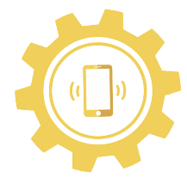 | EVALUATE AND SHARE  - Limitations  - Is the lung capacity of each person testing the same?  - How could the lung volume be measured with the materials provided?  - Are there any highlighted similarities/differences of;  - Lung capacity for each student  - Male / female students  - age  - students with lung/breathing conditions  - Significance and relevance of the data when designing a respiratory system  - Compare and justify he data between groups and discuss variables  TASK:  Outline experiment procedures, results and evaluation below.

EXPERIMENT

RESULTS / EVALUATION

LESSON 2: RESPIRATORY RATE, INHALE : EXHALE RATIO
BACKGROUND
“You need to do some basic investigations into the lungs and different breathing patterns in order to help you design the ventilator, and program it to deliver the right breaths to a patient.
Context is extremely important for engineering, and your supervisors wants to make sure you know everything you can before you start to design anything. You will need to research the effect if COVID-19 on the lungs, and what current measures are being taken by doctors to help treat patients.
Now that you know what kinds of topics you want to investigate (breaths per minute, inspiratory/expiratory ratio (inhale : exhale ratio)), and why this is helpful to your design process, your supervisors wants you to design these investigations and perform them, with the help of your co-workers.”
STEM PROCESS | TASK | STUDENT WORK/ NOTES
RESPIRATORY RATE, INHALE : EXHALE RATIO
DEFINE the problem
- What investigations are relevant in saving a life during COVID-19 Pandemic?

Introduction:
Watch: COVID – 19 – Information from the Department of Health
- Why do we need ventilators?
- How many more nurses and beds were needed to manage the pandemic in Australia? Therefore, how many more ventilators?
- Why is importing ventilators challenging?
- What technologies were used to assist production of ventilators?
- What are the complications that come from COVID-19? What is happening inside the lungs during COVID-19?
- What are the current measures taken to assist patients who are affected by COVID-19?
- How does a respiratory system help?
- What topics were thought of to investigate further to build knowledge?
THINK
Watch: Ampcontrol Video: Mikhaila Halford Learning and Development Specialist
- After hearing from Mikhaila, how did a range of experience assist the Ventilation project?
- What career pathways or opportunities are there in the industry and why are they important?
- What is inhale : exhale Ratio?
- Why is this ratio important to understand throughout the designing process?

CONSTRAINTS
- Discuss as a class and outline the constraints for the task

BRAINSTORM
Watch: Ampcontrol Video 4: Michael Cotton – Electronics technician
  - How was Michael’s role important and what was the brief when designing the ventilator?
  - What issues occurred during the project?
  - What could have assisted the process when creating the project?
  - What technologies were used to create designs?

Collaboratively with a partner or small group, brainstorm and document the following:
- How can lung volume from previous experiments be useful?
- How long does it take to deliver this volume (inhale)?
- How long does it take to empty back out (exhale)? (inhale : exhale ratio)
- How many times should this be delivered in a minute? (breaths per minute)
- What are the current measures taken to assist patients with COVID-19?
- What are the complications that come from COVID-19? How does it affect the lungs?
- What is normal breathing?
- What is a respiration rate?
- How do you measure the respiratory rate?
- What are the variables that can affect this rate?
- Is respiratory rate at rest or when active more relevant in a clinical ventilator setting?
- How to determine the average respiratory rate per minute?
- How testing will be completed for active respiratory rate?
- What is a reliable source to compare data?
- How is this determined?
- Effect of oxygen on the brain
- How can breathing be brought back to normal quickly?
- What is inspiratory-expiratory ratio?
- How is this different to respiratory rate?
- How do you measure inspiratory-expiratory ratio?

RESEARCH AND PLAN

WATCH: Ampcontrol DEMONSTRATION: Breaths per minute and Inhale: Exhale ratio
- Plan a scientific experiment to measure inhale : exhale ratio using points from the brainstorming session
- Why is the average respiration rate relevant?
- Plan how to find the average breath rate amongst a group of people
- Discuss and plan for the variables that need to be considered
- When would an active rate be useful?
DEVELOP AND MAKE
- Conduct scientific experiment and record data
- Create a graph measuring breaths per minute
- Prepare a formula to find the average of the results; individuals/ group
TEST AND IMPROVE
Static testing
- One student breathes while another student times.
- To calculate breaths per minute: count the number of breathes in 15 seconds x 4
- To find inhale : exhale ratio, use the ‘lap’ feature on the stopwatch to time the inhale and exhale times for a couple of breaths
- Find the average of the ‘lap’ times and find the ratio
After exercise
- Complete the same tests after exercise
- Collect data
EVALUATE AND SHARE
- Why is this testing relevant?
- Who is this information useful to in the development of the respiratory system?
- What were the limitations?
- Justify why data may vary from the experimentation?
- What information might need to be investigated further?
- Compare the data between groups and discuss variables
TASK:
- As a continuation within the final report, include the findings from the experimentation and the following topics below:
  - Breaths per minute
  - Inhale : Exhale ratio
  - Define what things are, include experiments you have conducted and findings as a result.
  - Design process and procedures

EXPERIMENT

RESULTS / EVALUATION

EXTENSION WORK
STEM PROCESS | TASK | STUDENT WORK/ NOTES
 | DEVELOP AND MAKE  - Write a basis C code which will take user input and then calculate lung volume, inhale : exhale ratio and breaths per minute  Include:  - The code  - Logic flowchart  - Logic instructions | Coding Program: www.onlinegdb.com  - Click the green run button to run the code  Full instructions for coding with some explanations are in the ‘C Coding for your PEMS’ document and full code is in the ‘STEM Coding file
TEST AND IMPROVE
- Test the code works
- Improve where needed

EVALUATE AND SHARE
- Evaluate how this could assist during the production of the respiratory system
- Share with your peers how the code works and will assist a respiratory system
TASK:
- As a continuation within the final report, include the findings from the experimentation on:
  - Code
  - Logic flowchart and instructions

EXPERIMENT

RESULTS / EVALUATION

LESSON 3: LUNG COMPLIANCE
BACKGROUND
“Every single person’s lungs are different. Not only does everyone have a different lung volume, everybody also has a different respiratory rate, both demonstrated by previous investigations. What causes this? What else differs between people’s lungs, and is there a difference between one individual's two lungs? What is lung compliance?”
STEM PROCESS | TASK | STUDENT WORK/ NOTES
LUNG COMPLIANCE
DEFINE the problem
- Without technology could we accommodate individual lungs during a pandemic?
Introduction:
- What is lung compliance?
- How do you test for/ measure lung compliance?
- What technologies could help with measuring lung compliance?
Watch: Ampcontrol Video5: Thomas Steigler – Research Engineer
- What types of engineering was involved within the ventilation system?
- What was needed to be researched?
- What were the biggest challenges?
Watch: Ampcontrol VIDEO 6: Ryan Boyle – Product Engineer
- What Is an embedded system?
- How did these systems help the ventilator project?
- How did you plan the system?
- How has Ryan and Ampcontrol assisted during the Pandemic?
THINK
Watch: The Respiratory System: Lung Compliance – Transpulmonary Pressure
- What can the lungs be described as?
- What does lung compliance mean?
- What does Transpulmonary Pressure mean?
- What factors reduce lung compliance?
CONSTRAINTS
- Discuss as a class and outline the constraints for the task

BRAINSTORM
- How do we know that lung compliance exists?
- From the Define and Think cog, define the problem
- What does lung compliance mean in the context of COVID-19?
- What needs to be considered when designing a ventilator?
- How can we demonstrate lung compliance?
- Discuss the variables that can assist the collation of data / make the testing easier / harder to represent lung compliance in different people
- Will there be a technology element to assist?
Brainstorm how lung compliance can be demonstrated using only the materials provided. Use discussion, drawings and develop a procedure.
RESEARCH AND PLAN
- Develop a procedure to demonstrate lung compliance
- Research further what is lung compliance
- Outline how the data will be collated to demonstrate how to improve lung compliance
- What will the testing of lung compliance look like?
- Plan the investigation for testing compliance

DEVELOP AND MAKE
- Conduct scientific experiment and record data
- Create the practical components for the collation of data of simulated lung compliance
TEST AND IMPROVE
- Create the practical components for the collation of data of simulated lung compliance
- Complete a variety of tests using the difference materials provided
- Record, graph and analyse data
- Improve on these findings by making variables to testing
EVALUATE AND SHARE
- Evaluate your design
- What did the testing demonstrate?
- What improvements could be made to improve lung compliance?
- Share your data with other groups – what were the differences between the groups?
- Were there a variety of variables to consider?
- Is there a better way to demonstrate lung compliance?
- Why is this testing relevant?
- Who is this information useful to in the development of the respiratory system?
- What were the limitations?
- Justify why data may vary from the experimentation?
- Compare the data between groups and discuss variables
TASK:
- As a continuation within the final report, include the findings from the experimentation on:
  - What is lung compliance?
  - How this investigation is important to the research and design of a ventilator system
  - What are the implications of compliance are there on an ventilator system?
  - How can you demonstrate lung compliance – ensure to include sketches of design with annotations and photos of the experimentation and testing
  - Also include graphs and data to support your justification

EXPERIMENT

RESULTS / EVALUATION

LESSON 4: BUILDING A VENTILATION SYSTEM
BACKGROUND
You are an engineer at Ampcontrol, employed to assist in creating a ventilator system. With the information that has been learn in the last three topics, design a system that simulates ventilation and air flow that could assist a person who has contracted COVID-19

STEM PROCESS | TASK | STUDENT WORK/ NOTES
BUILDING A VENTILATION SYSTEM
DEFINE the problem
Watch: Ampcontrol VIDEO 7: Ian Webster – Group Engineering Manager
- What does an engineering manager do and how did Ian contribute to the ventilator project?
- How was the work organised? Create a flow chart of the work flow /system streams.
- What were the constraints and issues that Ampcontrol faced?
- Why is teamwork important?
Watch: Ampcontrol VIDEO 8: Aaron Breese – Senior control and systems engineer
- What role did Aaron play within the ventilation project?
- What processes were taken to plan and deliver?
- What experiences have assisted Aaron’s understanding towards his current role?
THINK
In groups students are to design a simulated respiratory system
Define your task and discuss the constraints. You need to make a pump, why will that be hard? Consider the following points:
- What skills do you have within your group and how can you effectively contribute to the creation of the ventilator?
- What materials do you have available? Could you use a bike pump if all else fails? Do not forget the first video you watched about how Ampcontrol overcame their drawbacks.

CONSTRAINTS
- Discuss as a class and outline the constraints for the task

BRAINSTORM
WATCH: How do ventilators work?
- Brainstorm what areas / topics that need to be investigated more before designing can take place?
- Will the system involve technology or automation?
- Is the system an open / closed?
- What materials / products will be needed to create the system
- Representation of the practice
- Materials to use to create a prototype
- Role and responsibilities of the group members
- Timing for practical and presentation elements to be completed
- Technology / platform to deliver the presentation
- What information do you already have, how can this be used?
- Will you use any technology or automation?

- Are there any extra materials you might need? Any extra parts?
- How might you create pressure to fill the lungs?
RESEARCH AND PLAN
- Research brainstormed topics
- Research and plan ideas of creating simulation ventilator system
- Draw concept ideas for possible solutions
- Collect materials which can simulate the respiratory system
DEVELOP AND MAKE
Task:
Utilising research and knowledge acquired from this unit, build a ventilator ‘pump’ system using the equipment above.
WATCH:
Ampcontrol DEMONSTARTION: Pump Assembly
- Develop and make a basic assembly of the pump
TEST AND IMPROVE
- Test and see what works
- Make reiterations of your design and improve what you can
- Create some test lungs
- Using plastic freezer bags and cardboard, and hook everything up
- Use your pump to inflate the lungs to simulate an inhale, and then let the air flow out to simulate the exhale
- Are there elements within the constraints that are too restrictive?
TASK:
- Identify and improve ONE improvement
- Draw and annotate why this would be an improvement on the pump
EVALUATE AND SHARE
Task:
- Justify your pump design and include this in your final report
- Discuss the ventilator design with the testing phase
- Write a results paragraph, and include an evaluation
- Include photos and annotations of the process you have taken

STEM PROCESS | TASK | STUDENT WORK/ NOTES
EXTENSION WORK
DEVELOP AND MAKE
Micro:bit
Use a microbit controller to turn the pump on and off to match the breaths per minute and inhale : exhale ratio that you found. Connect the microbit to your servo motor as follows:
*please note; ‘Ground wire’ – shown in blue, however in Australia is typically black. The system can also be run without the ‘Purple wire running to 0’.

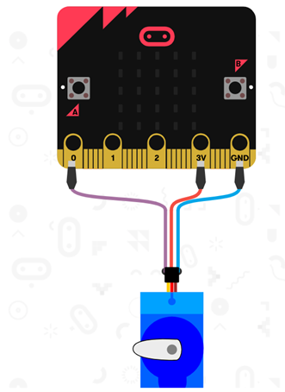
Using a micro:bit and the microbit.org website, two tasks can be completed;
Example 1:
input.onButtonPressed(Button.A, function () {
pins.servoWritePin(AnalogPin.P0, 180)
basic.pause(1000)
})
input.onButtonPressed(Button.B, function () {
pins.servoWritePin(AnalogPin.P0, 0)
basic.pause(1000)
})
Example 2:
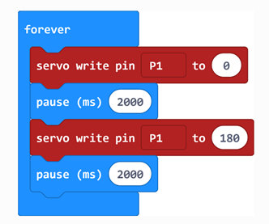
TEST AND IMPROVE
Example 1 discussion question:
- Does the code work?
- How could you use this code to simulate inhale : exhale ratio?
- How can this model be improved?
Example 2 discussion questions:
- Does the code work?
- Discuss what each block code means?
- What changes would you make to the block coding to simulate your calculated inhale : exhale ratio?
- Can this code be improved further?
EVALUATE AND SHARE
Task:
- Justify your pump design and include this in your final report.
- Outline and discuss the ventilator design throughout the testing phase
- Consider and address the challenges which were managed during the process
- Justify choices for the final solution and explain their benefits
- Write a results paragraph, and include an evaluation.
- Include photos and annotations of the process you have taken

EXPERIMENT

RESULTS / EVALUATION

FINAL REPORT CONCLUSIONS
From class work, experimentation and building of the ventilator system, discuss and evaluate your final design. Ensure you:
- Consider and address the challenges you experienced,
- Justify your decisions from what you learnt during your class work
- Provide drawings with annotations
- Pictures of the process you took to create the final product
- Include all plan and working drawings

FUTURE WORKS

APPENDICIES

